Python Ecommerce Website Output

[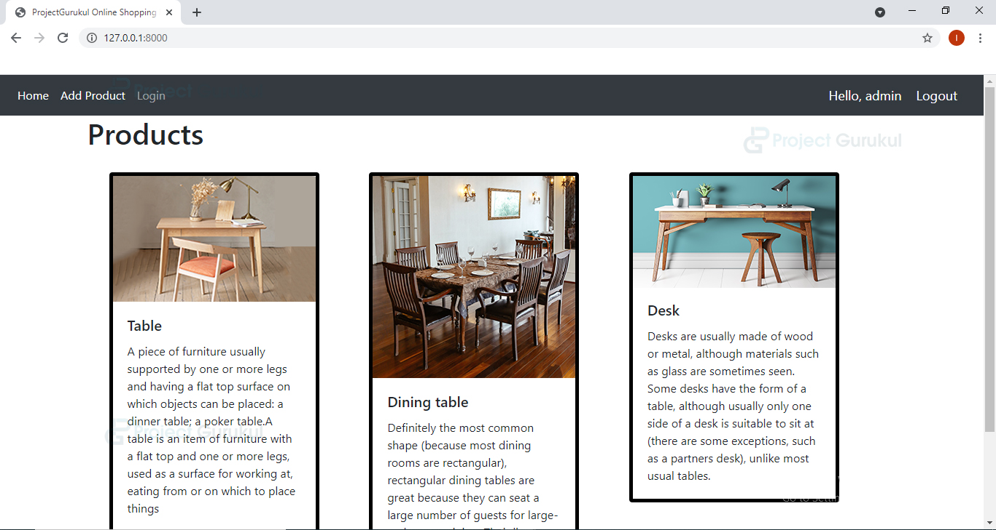](https://projectgurukul.org/wp-content/uploads/2021/05/ecommerce-admin-home.jpg)

[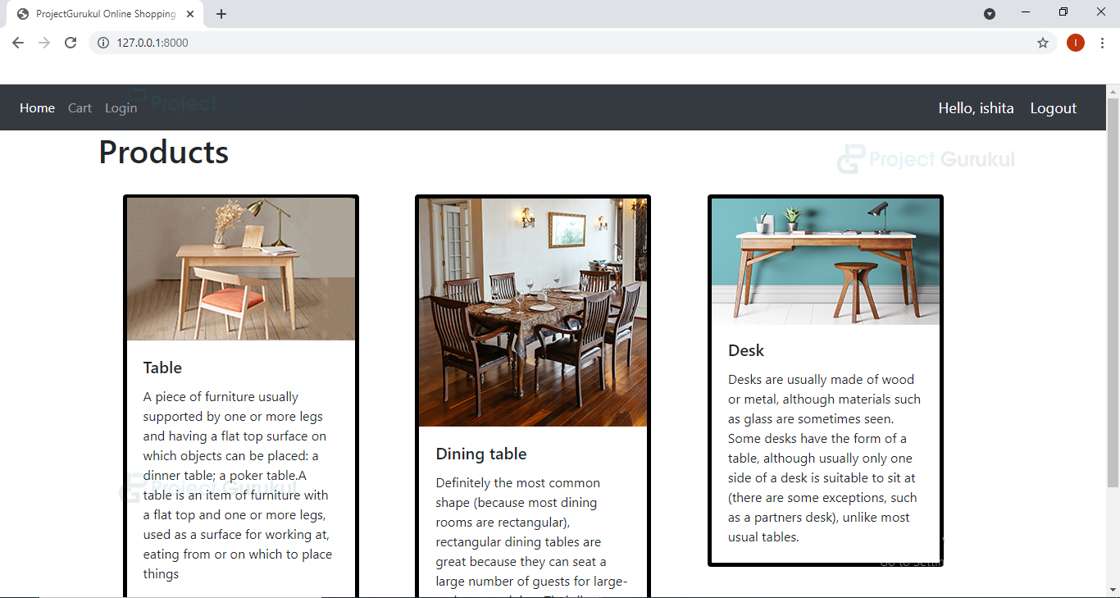](https://projectgurukul.org/wp-content/uploads/2021/05/ecommerce-customer-home-page.jpg)

[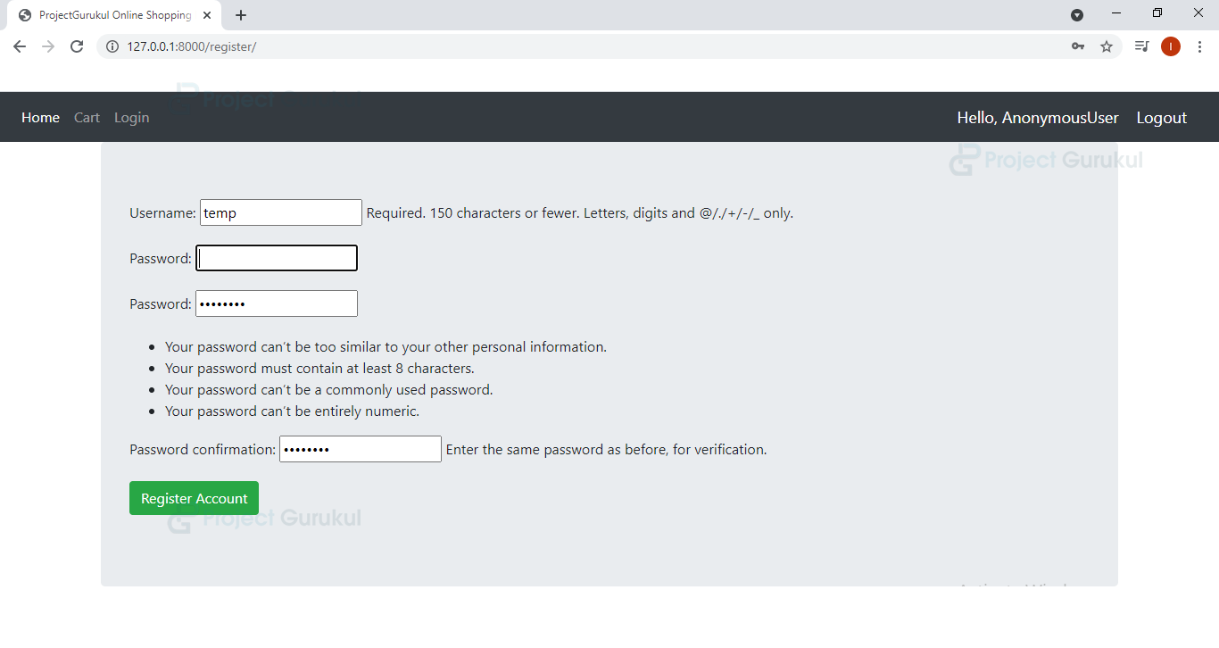](https://projectgurukul.org/wp-content/uploads/2021/05/ecommerce-register-page.png)

[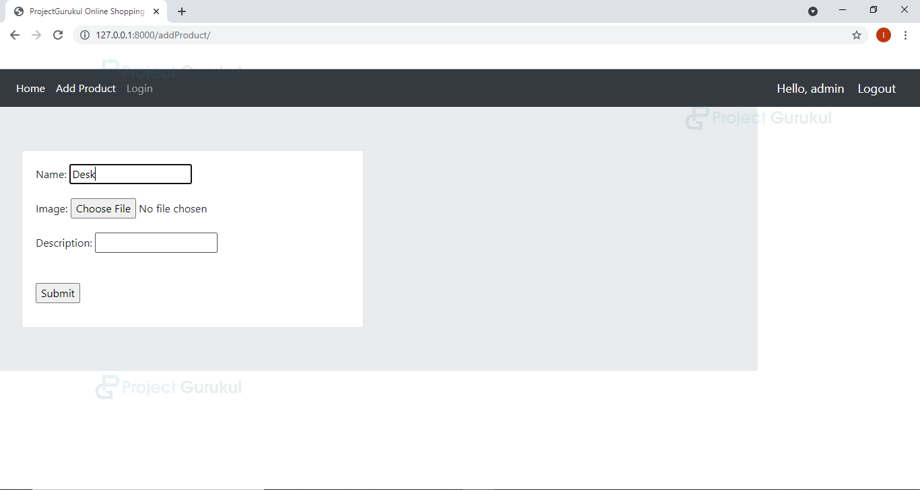](https://projectgurukul.org/wp-content/uploads/2021/05/add-product-ecommerce.png)